**Technical Documentation**

**Hacking Health Covid-19**

**Module 6: Interactive mapping Dashboard**

**Team 6:**

* Sireesha Namballa
* Yoni ATTIA
* Naveen Vijaykumar

**Interactive mapping Dashboard (with Time slider)**

This Coronavirus Interactive mapping dashboard provides an overview of the 2019 Novel Coronavirus COVID-19 (2019-nCoV) epidemic. This dashboard will be built with R and can easily reproduced by others. This Interactive map dashboard represents current and historical situation of Covid-19 pandemic effect across the world (using data of confirmed cases). The interactive Map comes with both time slider and Choropleth color palette

**Data:**

The source of this raw data pulled from the Johns Hopkins University Center for Systems Science and Engineering (JHU CCSE) and it is currently stored in the GitHub [repository](https://github.com/RamiKrispin/coronavirus-csv) of Rami Krispin. The data is refreshed daily.

**Expected Output:**

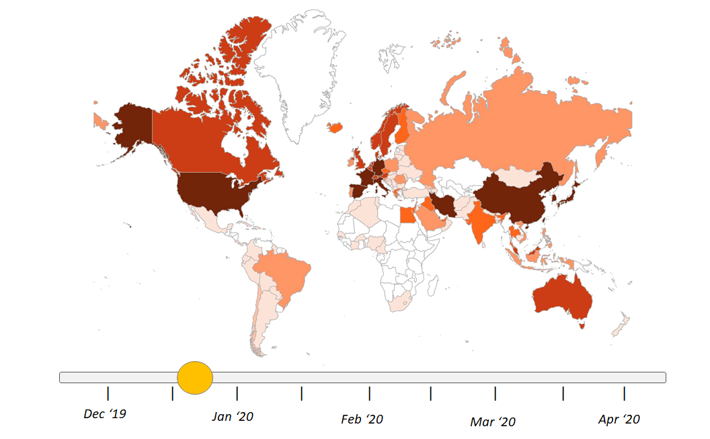

**Russia**

256 confirmed Cases

**Data frame**

* Province.State, Country.Region, Latitude, Longitude, Date, Cases (No. of Cases) and Type (confirmed, recovered, death)

**R Packages:**

* Visualization: ***leaflet*** for interactive map, ***RcolorBrewer*** for color palette, ***tmap*** for map settings,
* Data manipulation – ***dplyr, geojsonio***
* Time series plots: ***ggplot2, plotly, Shiny***

**Sample Features**

* Choropleth of Confirmed cases on World Map (Country wise & province/State wise)
* Time slider option: Map varying with time series function.
* Zoom In & Zoom Out:

**Functions** *(not exhaustive)*

* read_xlsx(): read the csv file
* head(): separate the headers in the csv file
* aggregate(): Cumulate the confirmed cases for each country (Province & country)
* RColourBrewer(): Color palette
* Add legend(): Add legend to the interactive Map
* Paste(): Text on Country
* ggplotly(): plot numeric time series
* reactive(): Slider value to filter the time series data
* addTimeline(): interactive slide option for timeline control
* geojson_json(): convert data.frame to json string

**Virtual Campus:**

* Data Visualization with R: Interactive Maps <https://virtualcampus.skemagloballab.io/posts/datavisualizationwithr3/>
* Interactive Maps: <https://blog.skemagloballab.io/posts/2020-01-28-interactiveMaps/>
* <https://virtualcampus.skemagloballab.io/posts/mappingspatialanalysiseconometrics/>
* <https://virtualcampus.skemagloballab.io/posts/dashplotly/>

**Open Source Details:**

* Data source: <https://raw.githubusercontent.com/RamiKrispin/coronavirus-csv/master/coronavirus_dataset.csv>
* Existing Dashboard: <https://ramikrispin.github.io/coronavirus_dashboard/>
* GitHub: <https://github.com/RamiKrispin/coronavirus_dashboard>

**Supporting Resources:**

* <https://support.sisense.com/hc/en-us/community/posts/360038301533-Plotly-Choropleth-With-Slider-Map-Charts-Over-Time-> (inspiration from python)